Caleb Ashitey-Amarh, John Darnell, Ashley Robbins
CEN6940 Computing Practicum
Milestone Report 2 - Data and Data Exploratory Analysis

Section 1: Data

This section documents the structure of the merged Rossmann dataset, which combines daily store-level transactions with store metadata, promotional schedules, and competitive context. The data span January 1, 2013 through July 31, 2015 and cover 1,115 stores, yielding 1,017,209 store-day observations. Each row represents one store on one calendar day, with Sales serving as the modeling target and the remaining fields providing candidate explanatory features: operational status, customer traffic, promotion indicators, holiday calendars, store classification, and competitor proximity. Table 1 defines each column and its data type, and Table 2 reports descriptive statistics for the numeric variables, establishing the distributional facts — skewness, structural missingness, and dispersion — that motivate the preprocessing and feature-engineering choices made later in the analysis.

Table 1. Data Column Descriptions
Column | Description | Type
StoreID | Unique store identifier (1–1,115). | int64
Date | Calendar date of the observation. | datetime64
DayOfWeek | Numeric day of week (1 = Monday … 7 = Sunday). | int64
DayName | Day-of-week name label. | str
IsOpen / Open_Flag | Indicator that the store was open on the given day. | int64
StoreClosed_Flag | Inverse indicator marking closure days. | int64
Sales | Total daily sales (turnover) for the store — the target variable. | int64
CustomerCount | Total daily customers entering the store. | int64
DailyPromo | Indicator for an active day-level promotion. | int64
StateHoliday | State holiday type/category. | str
SchoolHoliday_Flag | Indicator that the store-date was affected by a school holiday. | int64
StoreType / StoreType_Code | Store format/classification (4 categories). | str
Assortment / Assortment_Code | Product assortment class (3 categories). | str
CompetitorDistance_m | Distance to the nearest competitor in meters. | int64
CompetitorDistance_Imputed | Flag marking rows where competitor distance was imputed. | int64
CompetitorOpenMonth / Year | Month and year the nearest competitor opened. | float64
RecurringPromo | Indicator of participation in the recurring promotion program (Promo2). | int64
RecurringPromoStartWeek / Year | Calendar week and year the recurring promotion began. | float64
RecurringPromoMonths | Month intervals in which the recurring promotion is refreshed. | str
Year / Month / Quarter / Week | Calendar features derived from Date. | int
MonthName | Month name label derived from Date. | str
SalesPerCustomer | Derived ratio: Sales ÷ CustomerCount (average basket value). | float64

Table 2. Descriptive Statistics of Numeric Variables
Variable | Count | Mean | Median | Std | Min | 75% | Max
StoreID | 1,017,209 | 558.43 | 558 | 321.91 | 1 | 838 | 1,115
DayOfWeek | 1,017,209 | 4.00 | 4 | 2.00 | 1 | 6 | 7
IsOpen | 1,017,209 | 0.83 | 1 | 0.38 | 0 | 1 | 1
Open_Flag | 1,017,209 | 0.83 | 1 | 0.38 | 0 | 1 | 1
StoreClosed_Flag | 1,017,209 | 0.17 | 0 | 0.38 | 0 | 0 | 1
Sales | 1,017,209 | 5,773.82 | 5,744 | 3,849.93 | 0 | 7,856 | 41,551
CustomerCount | 1,017,209 | 633.15 | 609 | 464.41 | 0 | 837 | 7,388
DailyPromo | 1,017,209 | 0.38 | 0 | 0.49 | 0 | 1 | 1
SchoolHoliday_Flag | 1,017,209 | 0.18 | 0 | 0.38 | 0 | 0 | 1
CompetitorDistance_m | 1,017,209 | 5,422.02 | 2,325 | 7,706.92 | 20 | 6,880 | 75,860
CompetitorDist_Imputed | 1,017,209 | 0.003 | 0 | 0.05 | 0 | 0 | 1
CompetitorOpenMonth | 692,161 | 7.23 | 8 | 3.21 | 1 | 10 | 12
CompetitorOpenYear | 692,161 | 2,008.87 | 2,010 | 4.46 | 1,990 | 2,013 | 2,015
RecurringPromo | 1,017,209 | 0.50 | 1 | 0.50 | 0 | 1 | 1
RecurringPromoStartWeek | 509,178 | 23.27 | 22 | 14.10 | 1 | 37 | 50
RecurringPromoStartYear | 509,178 | 2,011.75 | 2,012 | 1.66 | 2,009 | 2,013 | 2,015
Year | 1,017,209 | 2,013.83 | 2,014 | 0.78 | 2,013 | 2,014 | 2,015
Month | 1,017,209 | 5.85 | 6 | 3.33 | 1 | 8 | 12
Quarter | 1,017,209 | 2.29 | 2 | 1.08 | 1 | 3 | 4
Week | 1,017,209 | 23.62 | 22 | 14.43 | 1 | 35 | 52
SalesPerCustomer | 844,338 | 9.49 | 9.25 | 2.20 | 2.75 | 10.90 | 64.96

Three observations from Table 2 matter for modeling. First, mean daily sales (5,774) sit above the median (5,744), and the maximum (41,551) is more than seven times the mean. This is a classic signature of right skew driven by a small number of very high-volume store-days. Second, about 17% of store-days are closures with zero sales; these should be excluded or modeled separately, since they are deterministic rather than demand-driven. Third, CompetitorDistance_m is extremely dispersed (median 2,325 m, max 75,860 m), suggesting a log or binned transformation will represent competitive pressure more sensibly than the raw distance.

Section 2: Key Findings

This section presents the core findings of the exploratory analysis, organized in two parts. The first part walks through seven diagnostic figures that profile the dataset's structure and the main drivers of demand: the pattern of missing values (Figure 1), the shape of the sales distribution and the case for a log transformation (Figure 2), the relationship between customer traffic and sales (Figure 3), temporal trends and seasonality (Figure 4), promotional effects across store segments (Figure 5), pairwise correlations among numeric variables (Figure 6), and the sensitivity of anomaly detection to threshold choice (Figure 7). Together, these figures establish that sales are driven primarily by foot traffic, amplified by promotions whose impact varies by store type, and shaped by strong calendar seasonality. The second part applies these diagnostics in a focused outlier analysis of high-volume sales days, quantifying how outlier days differ from normal trading (Table 3) and examining three individual records whose characteristics warrant data-quality review before model training. The findings in this section directly motivate the feature-engineering and modeling choices proposed in Section 3.

Figure 1. Missingness by Column
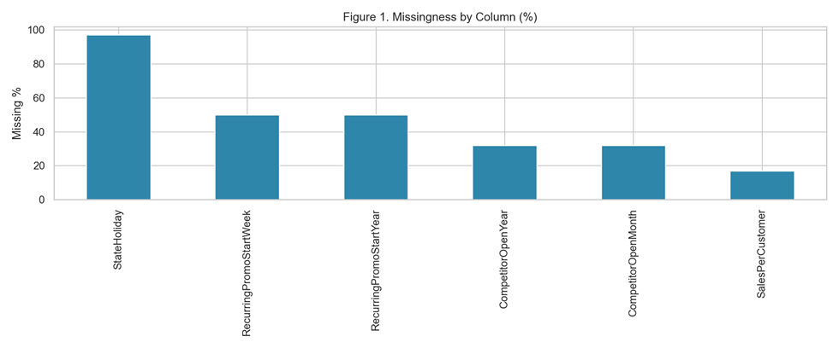Figure 1 shows concentrated missingness in a subset of fields, indicating non-random, structural missingness. This supports indicator-aware imputation for selected variables
Figure 2. Sales Distribution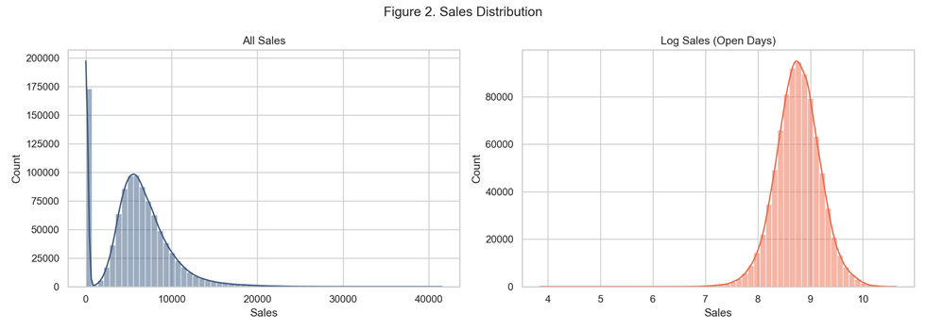
Figure 2 shows right-skewed sales distributions. The log transformation reduces skewness and improves stability for downstream models.

Figure 3. Sales vs CustomerCount
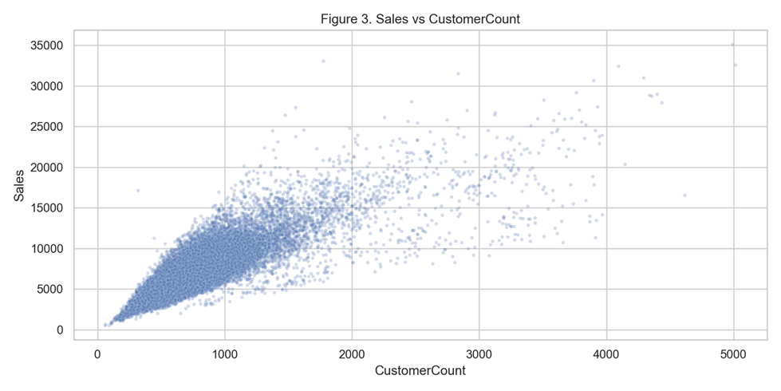
Figure 3 indicates a strong positive relationship between customer traffic and sales, suggesting traffic is a dominant short-term sales driver.

Figure 4. Daily and Monthly Trends
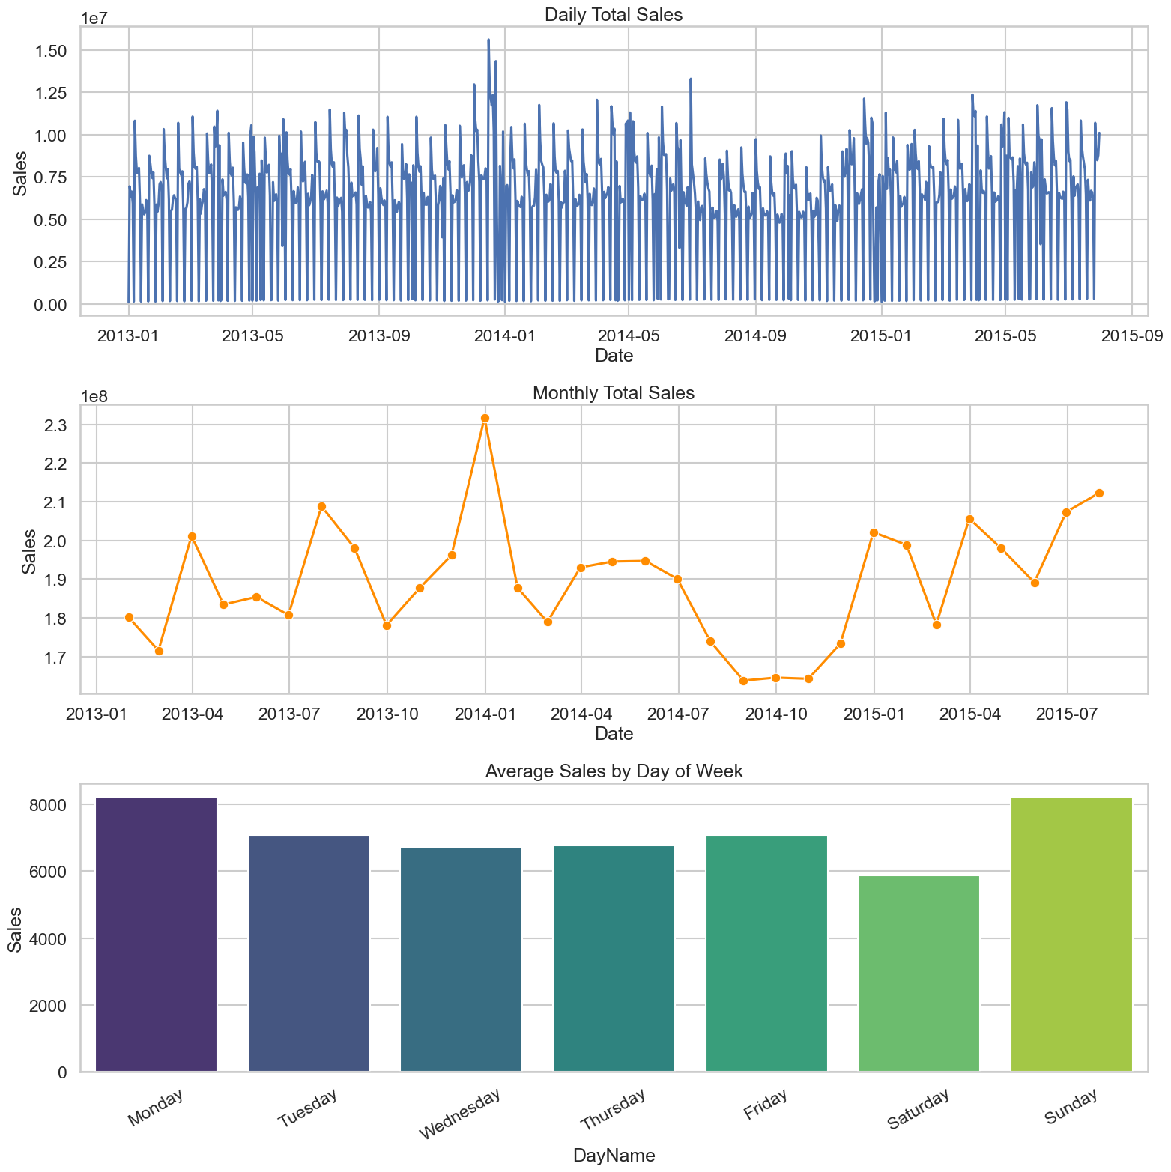
Figure 4 highlights nonstationary demand patterns and seasonality. Aggregate monthly trends are smoother and show systematic cyclical behavior.
Figure 5. Promo Effect by Sore Type

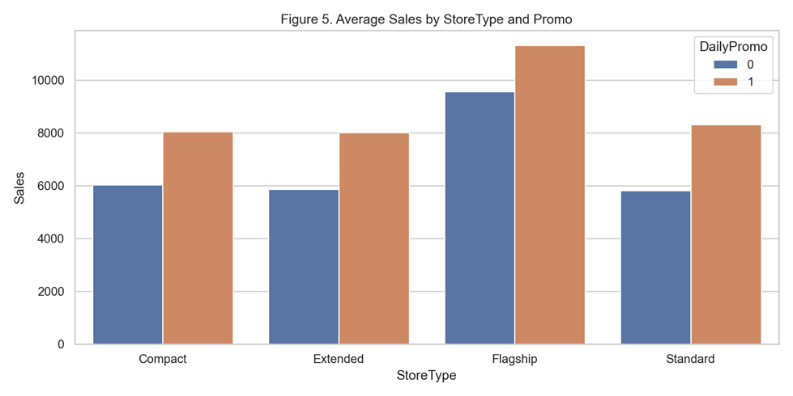
Figure 5 shows promotions raise average sales across store types, but effect size differs by segment, motivating interaction terms.
Figure 6. Correlation Matrix
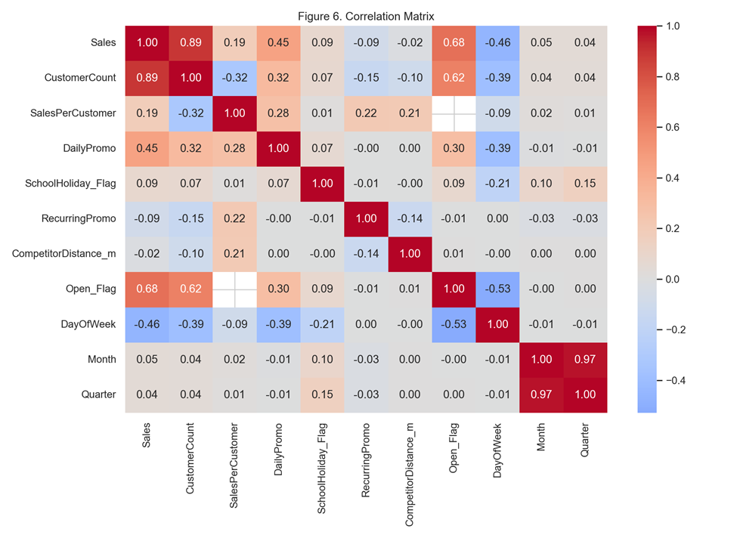
The Figure 6 heatmap summarizes pairwise linear relationships among the numeric variables. The dominant cell is the Sales–CustomerCount correlation of 0.89. DailyPromo shows a clear positive association with both sales and traffic. Calendar variables show weaker but non-trivial correlations with sales, and the open/closed flags correlate strongly with sales for the mechanical reason that closed days record zero. IsOpen and Open_Flag are perfectly redundant (and StoreClosed_Flag is their complement), so only one should enter any linear model to avoid multicollinearity.

Figure 7. Anomaly Sensitivity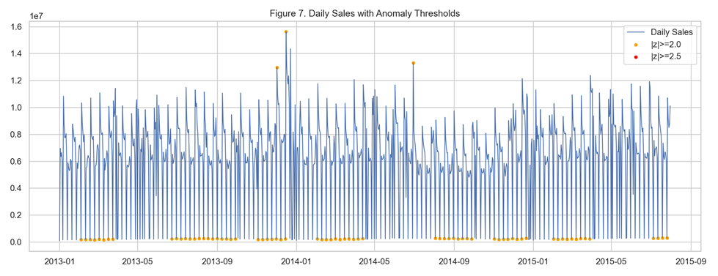
Figure 7 demonstrates anomaly detection sensitivity to threshold choice. Lower thresholds capture more events and are appropriate for monitoring workflows
Outlier Analysis — High-Volume Sales Days
An outlier threshold was established using the interquartile range (IQR) method. With Q1 at €4,859 and Q3 at €8,360, the IQR is €3,501, placing the upper fence at Q3 + 1.5 × IQR = €13,612. Any store day exceeding this value is classified as a high volume outlier. The lower fence resolves to a negative value (−€393), confirming there are no low-end sales outliers in the dataset.
Table 3. Normal Days vs. Outlier Days — Key Comparisons
Metric | Normal Days | Outlier Days | Difference
Record count | 813,569 | 30,769 | 96.4% vs. 3.6%
Avg. daily sales | €6,585 | €16,764 | 2.5× higher
Avg. customer count | 719 | 1,923 | 2.7× more traffic
Avg. sales per customer | €9.49 | €9.64 | Nearly identical
% with active promotion | 43.6% | 72.3% | +28.7 pts
% occurring in December | 5.5% | 17.3% | 3× over-represented
Flagship store share | 1.5% | 11.7% | 8× over-represented
Table 3 reveals the near identical average sales per customer between normal days (€9.49) and outlier days (€9.64) confirms that high volume days are not driven by customers spending more per visit. They are driven entirely by a surge in foot traffic. This means inventory and staffing models must treat customer volume as the primary lever, not basket size. The concentration of outliers in December (17.3% vs. 5.5% expected), on Mondays (35.6% vs. 15.6%), and at Flagship stores (11.7% vs. 1.5% of the base) provides a structured, predictable pattern that can be encoded directly as features in the demand forecasting model.
Within the 30,769 outlier records, three specific cases stand out for reasons that go beyond typical high-volume patterns and warrant individual review before model training.
Rank 1 — Store 909, June 22, 2015 (€41,551). This is the single highest daily sales record in the entire dataset. What makes it analytically suspicious is the combination of factors present: Store 909 is a Standard-type store with no active promotion and no holiday on the date in question, yet it recorded only 1,721 customers at a sales-per-customer ratio of €24.14 roughly 2.5 times the normal-day average of €9.49. Every other record in the top ten has a clear contextual explanation (Easter, public holiday, or Flagship store volume). Store 909 on this date does not. This record should be flagged as a candidate for data quality review before inclusion in model training, as it may represent a bulk purchase, a one-time promotional event not captured in the dataset, or a recording error.
Rank 40 — Store 126, October 24, 2013 (€33,071). This record holds the most extreme basket size in the top 100 outliers at €57.61 per customer, with only 574 customers recorded on the day. That combination of very few customers, very high revenue is inconsistent with typical retail foot-traffic dynamics and strongly suggests a non retail transaction recorded within the dataset (e.g., a wholesale or business-to-business order). Like Store 909, this record should be reviewed and, if confirmed as non-retail, excluded from demand models that target consumer-facing sales behavior.
Rank 91 — Store 726, December 16, 2013 (€31,311). Store 726 is notable not for data anomalies but for structural context: at 40,540 meters, it has the greatest distance to any competitor among the top 100 outlier records. Its high sales performance is likely explained by geographic monopoly rather than promotions, seasonality, or store format. This distinction matters for modeling the driver of demand here is the absence of alternatives rather than the factors that explain most other outliers. Including competitor distance on a log scale as a model feature, as proposed in Section 3, will help isolate this effect.

Section 3: Methods

Based on the exploratory findings, the next stage should combine an interpretable baseline with nonlinear methods, evaluated under a strictly time-aware protocol:
- Regularized linear regression on log-sales. Ridge or Lasso regression on the log-transformed target provides transparent, coefficient-level interpretation and a stable benchmark. The log target addresses the skew identified in Figure 2, and regularization guards against the redundancy flagged in Figure 6.
- Gradient-boosted trees and random forests. Tree ensembles capture the nonlinear effects and interactions the EDA surfaced — most importantly promo × store type (Figure 5) and saturation effects in the traffic–sales relationship (Figure 3) — without requiring those interactions to be specified by hand.
- Time-aware validation with rolling-window backtesting. Because the series is nonstationary and seasonal (Figure 4), models must be trained on earlier periods and evaluated on later ones, with the window rolled forward to test robustness across seasons. This prevents temporal leakage and yields honest estimates of out-of-sample forecast error.
- Feature strategy. Candidate features include lagged sales and lagged traffic, calendar indicators (day of week, month, holidays), promotion flags and promotion-cycle features, store metadata (type, assortment, competitor distance on a log scale), and missingness indicators for the structurally absent fields identified in Figure 1.
- Anomaly-aware preprocessing. Following Figure 7, anomaly handling should be split by purpose: a sensitive low-threshold detector for ongoing monitoring, and a conservative high-threshold rule for cleaning training data so genuine seasonal spikes are preserved.
- Model interpretation should accompany model fitting: SHAP values for the tree ensembles and coefficient analysis for the linear baseline will make it possible to verify that the models rely on the drivers the EDA identified, rather than on artifacts.

References

Haque, M. S., Amin, M. S., & Miah, J. (2023). Retail Demand Forecasting: A Comparative Study for Multivariate Time Series. arXiv:2308.11939. https://arxiv.org/pdf/2308.11939

Januschowski, T., et al. "Forecasting with Trees." International Journal of Forecasting https://www.sciencedirect.com/science/article/pii/S0169207021001679

Hyndman, R. J., & Athanasopoulos, G. (2021). Forecasting: Principles and Practice (3rd ed.). OTexts.
https://otexts.com/fpp3/tscv.html

Bandara, K., Bergmeir, C., & Smyl, S. (2020). "Forecasting Across Time Series Databases Using Recurrent Neural Networks on Groups of Similar Series." Expert Systems with Applications, 140.
https://www.sciencedirect.com/science/article/pii/S0957417419306128

Kaufman, S., Rosset, S., Perlich, C., & Stitelman, O. (2012). "Leakage in Data Mining: Formulation, Detection, and Avoidance." ACM Transactions on Knowledge Discovery from Data, 6(4).
https://dl.acm.org/doi/abs/10.1145/2382577.2382579

Gupta, M., Gao, J., Aggarwal, C. C., & Han, J. (2014). "Outlier Detection for Temporal Data: A Survey." IEEE Transactions on Knowledge and Data Engineering, 26(9), 2250-2267.
https://ieeexplore.ieee.org/abstract/document/6684530

